37.6: 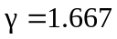 a) 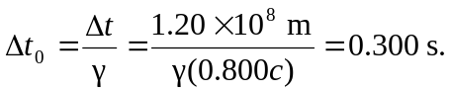
b) 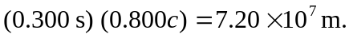
c) 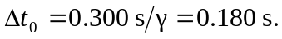 (This is what the racer measures your clock to read at that instant.) At your origin you read the original 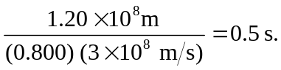
Clearly the observes (you and the racer) will not agree on the order of events!

